Kompetenzen | Mündliche Interaktion (Rollenspiele), Mediation (Notizen und Zusammenfassungen anfertigen), schriftliche Produktion, Online-Interaktion, Empathie und emotionale Intelligenz entwickeln
Niveau | B2
Themenbereiche | Empathy, Care, Interpersonal Relationships, Social Responsibility
Methoden | Kooperatives Lernen, Diskussion, Technologieunterstütztes Lernen, Kreative Produktion, Rollenspiele, Reflexion
Zeitbedarf | 3-4 Einheiten
Eingangsvoraus-setzungen | S/S verfügen über grundlegende Fähigkeiten in der mündlichen und schriftlichen Kommunikation und haben Interesse an sozialen Themen und Empathie.
Materialien | Mobile Endgeräte
Quellen | Eigene Ideen  Video: Empathy and Kindness Video  Mahatma Gandhi Zitat: "The best way to find yourself is to lose yourself in the service of others"  Guide Inc Team Building Activity  Pinterest Quote
Details zur Aufgabe | In dieser Unterrichtseinheit geht es darum, das Verständnis und die Praxis von Empathie und Fürsorge zu fördern. Die Lernenden reflektieren, was es bedeutet, füreinander zu sorgen, und entwickeln durch verschiedene Aufgaben Fähigkeiten wie aktives Zuhören, Mitgefühl und selbstlose Handlungen. Sie erstellen ein „Web of Care“, diskutieren über das Gandhi-Zitat und lernen, wie kleine Taten der Freundlichkeit große Auswirkungen auf das Wohlbefinden haben können. Zudem vertiefen die Lernenden ihre Sprachkenntnisse durch Vokabelübungen und kreative Aufgaben wie das Erstellen von Comics oder Geschichten über Fürsorge und Empathie.  Answers – Task 3/1  - 1c – 2f – 3a – 4b – 5g – 6h – 7d – 8j – 9i – 10e  - ripple effect – gesture – inspire – pay it forward – chain reaction – selfless – boomerang – compassion/empathy – kindness – empathy/compassion

The Power of Care: Building Empathy and Connection

Task 1 – The Web of Care


Get a ball of yarn, string or rope. Team up in large groups of 8 to 10 and sit down or stand in a circle.
One of the group starts by holding the ball, sharing one word or phrase that describes what caring for others means to them, e.g. kindness, support, etc.
After sharing a word or phrase, hold on to a piece of the yarn, string or rope and throw the ball to another student.
Continue till everyone in the group has shared their words/phrases and a web has been formed.

Picture: AI generated

Task 2 – Pair/Group discussion

Team up with a partner or work in small groups (3-4 students).
“The best way to find yourself is to lose yourself in the service of others.”

Mahatma Gandhi

The web you created in the task before is supposed to stand for connectedness. Read the quote from Mahatma Ghandi, then briefly discuss the following questions:
- What does the quote mean to you?
- How can acts of care (big or small) affect the well-being of others and your own?
  - Find examples from your own life where someone’s care made a difference for you or when you helped someone in need.
- In what way can people show care at home, at school or in the wider world?

Task 3 – Listening

You are going to watch a video about empathy and caring. Before watching the video, do these vocabulary exercises.

- Match the expressions with their correct definitions. Draw lines.

- kindness | - a situation in which one event produces effects which spread and produce further effects
- boomerang | - a feeling of sympathy and understanding for another's pain
- ripple effect | - the act of being generous, considerate and friendly
- compassion | - the ability to understand and share the feelings of another person
- gesture | - to do something kind or useful for someone because someone else has done something kind or useful for you
- selfless | - a curved object that returns to the thrower after being thrown
- empathy | - an action that expresses something, e.g. holding the door open
- chain reaction | - caring for others, putting their needs before your own
- inspire | - to motivate or encourage others to do something positive
- pay it forward | - a set of related events in which each event causes the next one, or a chemical reaction in which each change causes another

- Now fill in the blanks, using the words above.

- The decline in the car industry had a _____________________ on the whole community.
- The cyclist made a rude ______________________ at the truck driver.
- It’s amazing how a small act of kindness can ____________________ someone else to do the same.
- I was so thankful for their kindness and generosity and promised to _____________________.
- The war risked setting off a _____________________ that would endanger the entire world.
- He was a _____________________ person who was deeply concerned about social justice.
- The company’s new investment plan could ___________________ on them if they are not careful.
- I have great _____________________ with people suffering from serious diseases.
- Don’t be fooled by their _____________________. It’s just a front.
- Some people feel great ____________________ with the poor.
- Answer these questions, using the words above.

- Can you think of an example where a small act of kindness had a large ripple effect?

- How do you think practicing empathy can change your relationships with others?

- What is something you’ve done recently to pay it forward?

- Why is it important to act selflessly, e.g. at home or at school?

Now watch the video. While watching, answer the questions below:

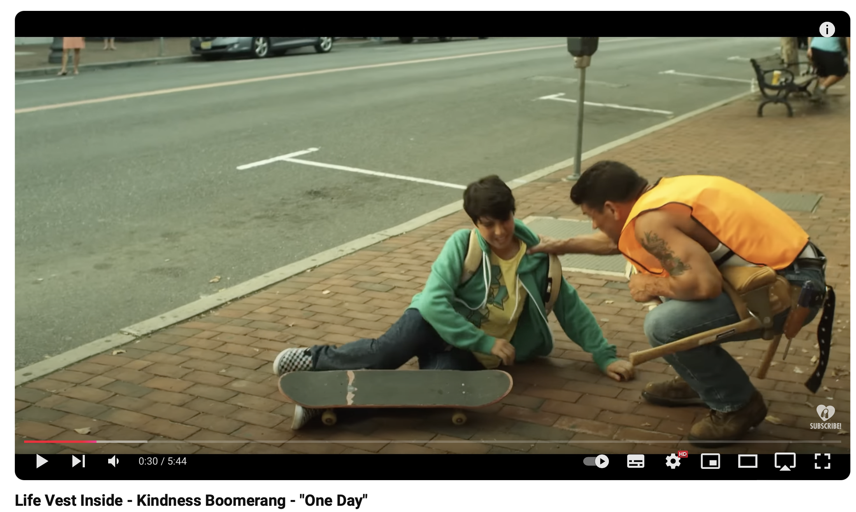


Source. https://www.youtube.com/watch?v=nwAYpLVyeFU

- What are some of the acts of kindness shown in the video?

- How does the kindness boomerang idea work?

- What message is the video trying to communicate about kindness?

Ideas for further activities

Task 4 – Vocabulary

- Team up in small groups (3-4 students per group). In your groups, work together to come up with phrases or actions related to kindness and caring in English. Possible categories:
- compliments, e.g. “You’re doing a great job.”
- helping others, e.g. “Can I help you with that?”
- acts of kindness, e.g. writing a thank-you note
- empathy phrases, e.g. “I understand how you feel”.

- Write them on slips of paper. Then rotate and review the other group’s phrases.
Add your own suggestions.

- Now work individually.
Choose 8 to 10 phrases from the list and create your own personalized BINGO cards. You may use an online BINGO generator like MyFreeBingoCards.com (https://myfreebingocards.com) or draw the cards by hand. Here is an example:

Acts of kindness

writing a thank-you note | doing a chore like cleaning up without being asked | donating clothes
holding the door for someone | giving someone a compliment, e.g. “You’ve done a great job!” | helping a classmate who is struggling with their homework

  - For two weeks perform the actions or use these phrases in real life. Mark off the completed actions and phrases on your cards. By the end of the specified time, have a look at which tasks you completed.

Task 5 – Writing tasks

Choose one of the following writing tasks:
- Design a comic strip that showcases a story about kindness and caring, e.g. comforting a friend or helping your neighbour. Use humour, creativity and empathy to bring your story to life. Use an online tool like Make Beliefs Comix (https://www.makebeliefscomix.com ) or draw it by hand. Create a short 5-panel comic. Share your comic by putting it up in class or uploading it to a digital platform like Padlet (https://padlet.com ).
- Write a short story of around 180 to 200 words about a time you witnessed or experienced an act of kindness that deeply affected you or someone else. Say …
  - what happened and who was involved
  - what the person did and why it was significant
  - how it made you or others feel and what its lasting impact was
Share your story with your classmates, e.g. by creating a class Acts of Kindness digital Padlet booklet (https://padlet.com ), or by reading out your story in class.
- Design posters with uplifting messages, e.g. “Be the reason someone smiles today”, and display them around your class or school.
- Design small cards with compliments or encouraging messages in English and give them to classmates or teachers.
- Write a short letter to a person you admire, e.g. a teacher. In your letter you should:
  - explain why you admire them
  - say why their actions or influence have affected you
  - thank them for their positive influence on your life

Task 6 – Speaking activity

Work in pairs or groups of 3-4 students and act out short roleplay scenarios that show caring or uncaring behaviour.
- First, decide on a scenario. Here are a few examples:
- a student feeling excluded at lunch
- a teacher struggling with a heavy bag
- a friend stressed about an upcoming English test
- a person who needs cheering up after receiving some bad news

- Then decide how to act it out. First time with care or empathy, second time without care or empathy.

- Follow-up discussion: discuss what the difference was between the two versions and how it felt to be cared for or not be cared for.

