Kompetenzen | Mündliche Interaktion (Rollenspiele und Debatten), Leseverstehen, schriftliche Produktion, kritisches Denken, digitale Medienkompetenz
Niveau | B2
Themenbereiche | Artificial Intelligence, Technology and Society, Human-Machine-Interaction
Methoden | Technologieunterstütztes Lernen, Gruppenarbeit, Rollenspiele, Debatten, Kreatives Schreiben
Zeitbedarf | 3-4 Einheiten
Eingangsvoraus-setzungen | S/S verfügen über Grundkenntnisse in den Bereichen Technologie und KI sowie Wortschatz zur Beschreibung von Eigenschaften und Emotionen.
Materialien | Mobile Endgeräte
Quellen | Eigene Ideen  Artikel: Can a fluffy robot really replace a cat or dog? My weird emotional week with an AI pet (The Guardian, 20. November 2024)  Mentimeter: www.menti.com
Details zur Aufgabe | Diese Unterrichtseinheit fördert das kritische Denken und die Auseinandersetzung mit der Rolle von KI in unserem Leben. Die Lernenden erweitern ihr Vokabular zu Emotionen, Technologie und praktischen Anwendungen, analysieren einen aktuellen Artikel, und reflektieren über die Implikationen von KI-basierten Haustieren. Durch Diskussionen, Rollenspiele und kreative Schreibaufgaben wird die Sprachkompetenz in realen und zukunftsrelevanten Kontexten gefördert.  Task 1 – teacher's rubric:  Sit comfortably in your chairs and close your eyes. Relax your shoulders, take a deep breath and slowly exhale. Now listen carefully.  I want you to imagine something in your mind. Imagine you have been given the chance to design your own artificial intelligence pet.  Imagine what it would look like.  - Would it look like a real animal, like a dog or cat? Or something completely different?  - What colour is it? How big is it?  - Think about how it moves. Does it walk, fly or roll?  - What special ability has it got? Can it talk? Play games?  - How does it interact with you? By speaking, touching, or through an app?  - How does it make you feel? Happy? Calm? Excited?  Now take a pencil and a sheet of paper and draw your artificial intelligence pet.
TechTools | Mentimeter, ChatGPT

AI in Our Lives: Can Robots Be Our Best Friends?

Task 1

- Listen to your teacher and follow their instructions.

- Team up with a classmate and tell each other about your artificial pet and its features.

Task 2

Go to www.menti.com. Key in the code you will receive from your teacher to join. Then answer the questions you will see at the top of each slide.
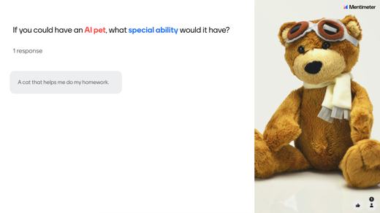

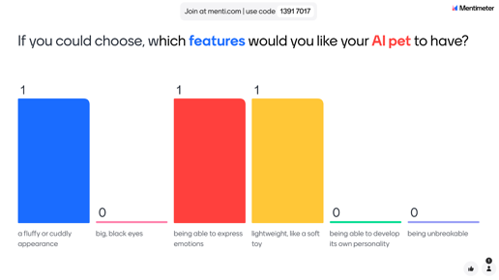

Task 3 – Vocabulary

- Match the English expressions below with their definitions and German translations.
Draw lines to connect them.

English | Definition | German
emotional evolution | a friend or pet that needs little maintenance | anpassbares Verhalten
to build emotional bonds | friendship without any major obligations | Benutzerinteraktionen lernen
to mimic real pets | to decrease feelings of worry or tension | echte Haustiere nachahmen
personalised responses | to create strong emotional connections | emotionale Bindungen aufbauen
to bridge technology and emotion | reactions tailored for an individual | emotionale Entwicklung
low-maintenance companion | the ability to provide emotional or physical support | fortschrittliche KI-Algorithmen
customisable behaviour | to understand and adapt to users’ behaviour | Freundschaft/Gesellschaft ohne Verantwortung
to learn user instructions | to adjust to the preferences or needs of a user | hochmoderne Sensoren
to reduce stress and anxiety | behaviour that can be tailored to fit preferences | KI-gesteuerte emotionale Unterstützung
AI-driven emotional support | to imitate the behaviour of real animals | personalisierte Reaktionen
to adapt to a user’s needs | to connect innovation with human emotions | pflegeleichter Begleiter
advanced AI-algorithms | support provided by artificial intelligence to comfort users | sich an die Bedürfnisse des Benutzers anpassen
cutting-edge sensors | the development of complex emotional responses | Stress und Angst reduzieren
companionship without responsibility | highly advanced devices used to detect changes | Technologie und Emotion verbinden
therapeutic potential | highly complex mathematical methods used in AI | therapeutisches Potential
- Now have a good look at the English expressions above. Try to group them into categories based on their focus: Emotions, Technology or Practical Features. Not all expressions will fit into one of these categories. Be ready to give reasons for your choices.

Emotions | Technology | Practical Features
- emotional evolution


Task 4 – Reading

You will now read an article about a man’s experience with an AI pet.

- Before you read the text, predict what the text will be about from its title:
“Can a fluffy robot really replace a cat or dog? My weird emotional week with an AI pet.”

- Scan the QR code, using your phone or tablet. It will take you directly to the article published on The Guardian website on 20 November 2024.

  - Quickly read the article. Check against the predictions you made about the text. Where you right? What do you think about what is said in the text? Is there anything that surprises, excites or shocks you?
Share your thoughts with the class.

  - Read the article again and pay attention to the author’s experiences and opinions about Moflin.
What do you find most interesting?

- Team up in small groups of 3 to 4 students and discuss the following questions:
  - Would you consider owning an AI pet? Why or why not?
  - How do you think AI pets could impact people’s lives, especially for those who can’t own traditional pets?
  - What do you find most fascinating or concerning about AI companions like Moflin?

Task 5 – Role-play

- Split up into two groups: one supporting AI pets (pro-AI pets) and the other opposing AI pets (against-AI pets).

- In your group, prepare strong arguments for or against AI pets. You can use an advanced AI language model such as ChatGPT (www.chatgpt.com ) to help you with ideas. You should also try to include vocabulary you’ve learned during this lesson in your arguments.

- Conduct the debate. Each group will present its arguments and respond to the other group’s points. Be respectful of each other’s viewpoints. Focus on presenting well-supported arguments.

- After the debate, provide a short summary of the key points discussed. Who found the most convincing arguments and why?

Task 6 – Writing

Choose one or more of the following writing tasks. Write about 200 to 250 words.
- Write an email to the editor of The Guardian and state your opinion on the article.
- Interview an AI pet about its experiences with humans. Write out the interview.
- Design an advertisement for an AI pet.
- Imagine you are an AI pet that has been passed on to a new owner. Write an email to your new owner. Share you experiences and offer advice on how to care for you.
- Imagine you have to give up your AI pet and pass it to a new owner. Write a farewell message to your pet. What did you learn from it? How did it affect your emotions? Describe any regrets or memorable experiences.
- Write a summary of the main points of the article.
  - What is Moflin and what is its purpose?
  - How does it simulate emotions?
  - Why are AI pets becoming popular in countries like Japan?
  - What are some of the benefits and downsides of owning an AI pet?

Task 3 – Key

English | Definition | German
emotional evolution | the development of complex emotional responses | emotionale Entwicklung
to build emotional bonds | to create strong emotional connections | emotionale Bindungen aufbauen
to mimic real pets | to imitate the behaviour of real animals | echte Haustiere nachahmen
personalised responses | reactions tailored for an individual | personalisierte Reaktionen
to bridge technology and emotion | to connect innovation with human emotions | Technologie und Emotion verbinden
low-maintenance companion | a friend or pet that needs little maintenance | pflegeleichter Begleiter
customisable behaviour | behaviour that can be tailored to fit preferences | anpassbares Verhalten
to learn user instructions | to understand and adapt to users’ behaviour | Benutzerinteraktionen lernen
to reduce stress and anxiety | to decrease feelings of worry or tension | Stress und Angst reduzieren
AI-driven emotional support | support provided by artificial intelligence to comfort users | KI-gesteuerte emotionale Unterstützung
to adapt to a user’s needs | to adjust to the preferences or needs of a user | sich an die Bedürfnisse des Benutzers anpassen
advanced AI-algorithms | highly complex mathematical methods used in AI | fortschrittliche KI-Algorithmen
cutting-edge sensors | highly advanced devices used to detect changes | hochmoderne Sensoren
companionship without responsibility | friendship without any major obligations | Freundschaft/Gesellschaft ohne Verantwortung
therapeutic potential | the ability to provide emotional or physical support | therapeutisches Potential

