Kompetenzen | Mündliche Interaktion (inkl. Interviewgespräche), Mediation (Notizen anfertigen), schriftliche Produktion, Online-Interaktion, Audio-visuelles Verstehen
Niveau | B1
Themenbereiche | Emotions, student wellbeing,
Methoden | Technologieunterstützes Lernen, Partnerarbeit, Individualisiertes Lernen
Zeitbedarf | 2-3 Einheiten
Eingangsvoraus-setzungen | S/S verfügen über einen ausreichenden Wortschatz zum Thema Gefühle, mentale und körperliche Gesundheit.
Materialien | Mobile Endgeräte
Quellen | Eigene Idee  Video: https://www.youtube.com/watch?v=3QIfkeA6HBY
Details zur Aufgabe | Mit dieser Aufgabe soll den Lernenden der nötige Wortschatz zur Vertiefung des Themas mitgegeben werden. Darüber hinaus ist es eine Möglichkeit den Lernenden Zeit zur Selbstreflexion zu genehmigen und in Teams zu überlegen, wie die eigene mentale Gesundheit verbessert bzw. stabil behalten werden kann.
TechTools | Canva, Quizlet, Padlet (oder ähnliche)

Thrive and Shine – Cultivating Student Wellbeing

Task 1
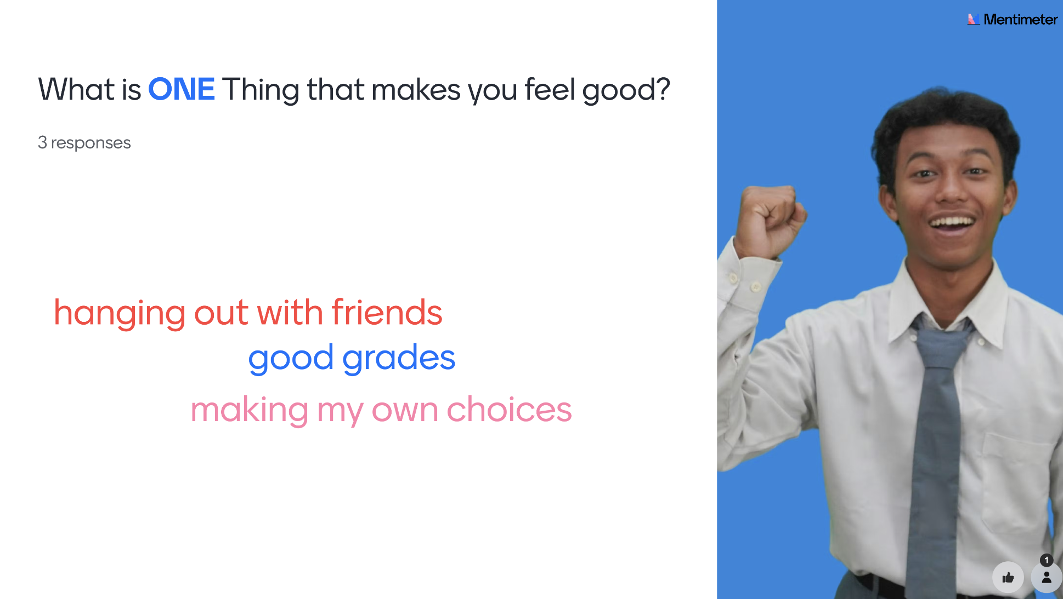
Go to www.menti.com. Key in the code you will receive from your teacher to join. Then answer the question.

Task 2 – Pair discussion
Team up with a partner. How do these things help students feel happier and healthier and contribute to student wellbeing? Share your ideas with examples to explain why they matter to you.

Task 3 – Viewing
Here’s a short video about student wellbeing.
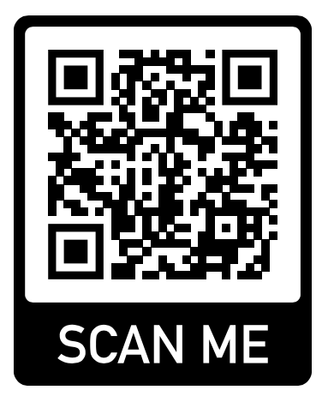
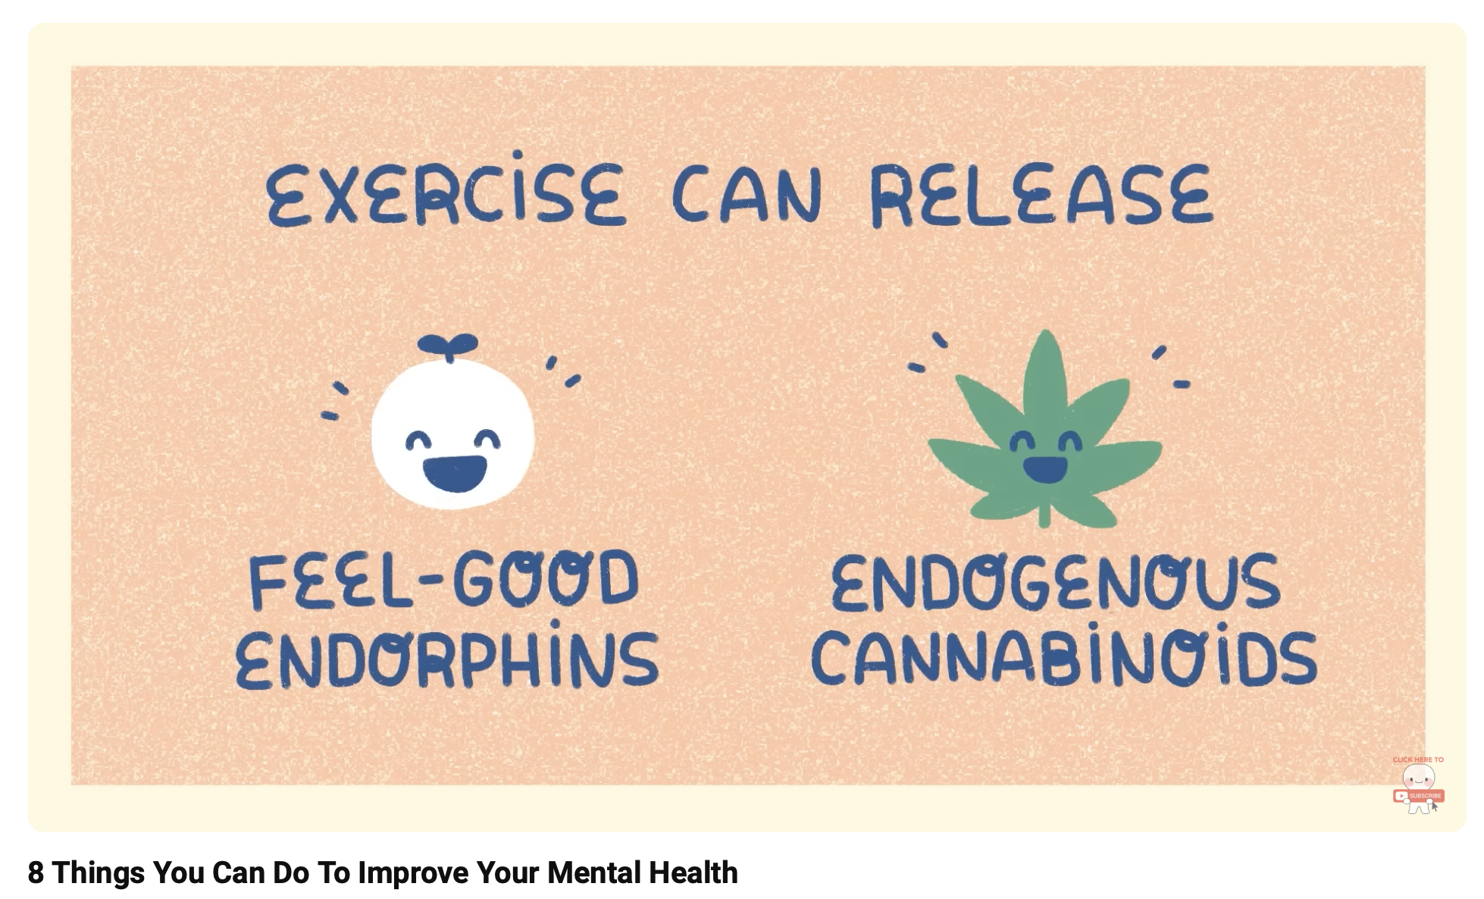

Source: https://www.youtube.com/watch?v=3QIfkeA6HBY

- Watch the video once without pausing or taking notes in detail. Just jot down the 8 things mentioned in the video that can help improve student wellbeing.

- Then watch the video a second time. This time, pause when necessary to take more detailed notes: how to do it, why it works, or any other tips the video shares.

- Complete the grid below.

- Now share your notes with a partner. Discuss which of the tips you already practice and what else you could do to improve your wellbeing.

Task 4 – Useful collocations
- Here’s a list of common collocations (word partnerships) split into two. Which two parts go together to form a meaningful collocation? Draw lines.

- manage or reduce … | - … confidence
- build … | - … with friends
- take regular … | - … between schoolwork and free time
- maintain balance … | - … breaks
- set clear … | - … effectively
- build … | - … stress
- foster good relationships … | - … study habits
- improve your physical … | - … goals
- strengthen … | - … mental resilience
- reduce anxiety … | - … and mental health
- manage your time … | - … before tests and exams
- focus … | - … motivation
- relax your … | - … on self-care
- increase … | - … quality
- improve sleep … | - … mind
- seek professional … | - … setbacks
- negatively affect … | - … your state of mind
- suffer several … | - … help
- ignore early … | - … warning signs
- develop good … | - … relationships

- Now create your own flashcards (e.g. with Canva, Quizlet or handwritten) for the collocations from the list. For each collocation, you could include:
  - a German translation
  - an English definition
  - an example sentence

Here is a Quizlet example:
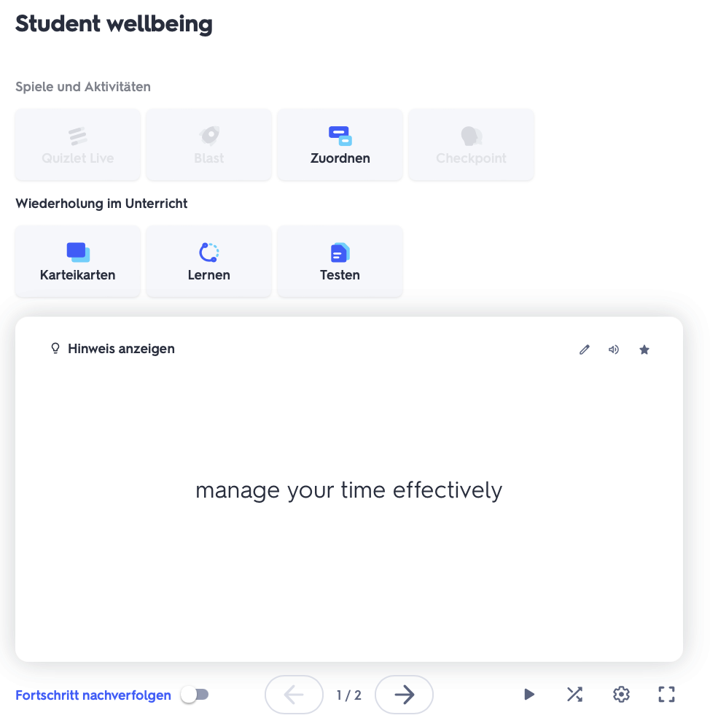

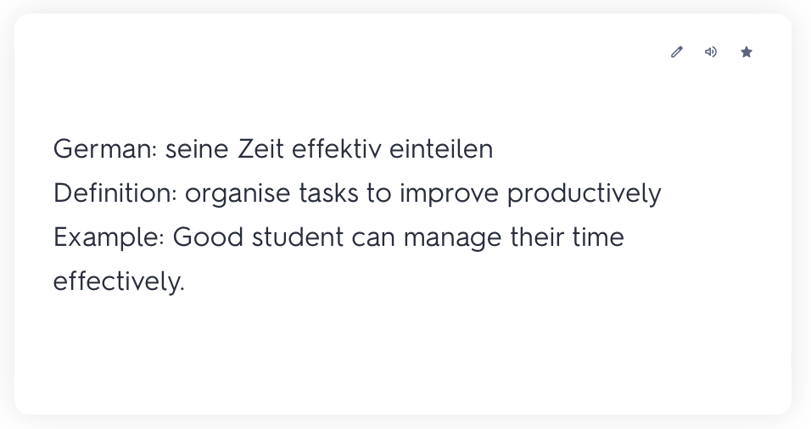

Review the phrases from time to time to remember them better!

Task 5 – Interaction

Work in pairs.

You and your partner are going to create an episode (about 5 minutes) for a popular student lifestyle podcast called Thriving Teens.

The podcast focuses on helping students to maintain a healthy balance between school and personal life. For this episode, one of you will play the host and interview a guest expert (the other partner) who will share tips and advice on student wellbeing.

- Decide on the focus of your episode, for example how to deal with exam stress.
  - Prepare some key questions for the interviewer to ask, such as, "What are the best ways to manage exam stress?"
  - The guest should brainstorm answers and provide practical tips and examples.
  - Create a simple outline or script to guide your conversation during the interview.
  - Record your podcast.
  - Send your podcast to your teacher.

When everyone has sent their podcasts your teacher will share the podcasts with you and you can listen to the other podcasts and leave meaningful comments on the tips and advice provided.

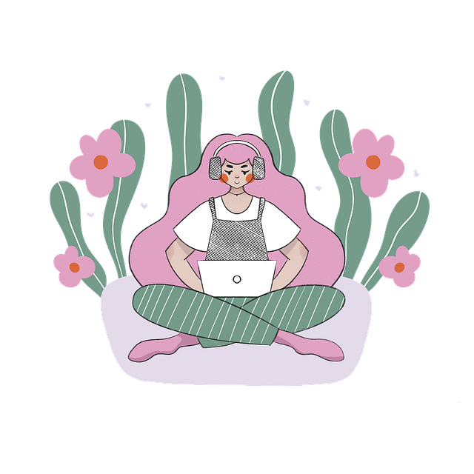
Task 6 – Designing and writing a leaflet
Work on your own.

Design a student wellbeing leaflet that gives useful tips and ideas for staying healthy and balanced as a student.

Here’s how you can do it:
  - Choose an online design platform like Canva (www.canva.com).
- Select a poster or infographic template to start your design.
- Organise your leaflet by dividing it into different sections such as stress management, healthy habits, relaxation, etc.
- Add icons, images and calming colours to make your leaflet look great.
- Add short texts that are easy to read and understand.
- Share your work digitally via Padlet (www.padlet.com). Your teacher will provide you with the link.
- Invite your classmates to read your leaflet and leave meaningful comments.

Task 7– Personal wellbeing goals envelope
Now think about the things you have learned about wellbeing. Which idea or ideas would you like to try practicing in your own life. Write them down. Here are a few examples to help you:
- Starting today, I will drink two litres of water every day.
- I plan to go to bed 30 minutes earlier each night.
- My goal is to eat less fast food in the next month.

Write each goal on a slip of paper and put it in an envelope. After some time, open the envelope and think about your progress.


Here are some useful sentence starters for you:
- My goal/aim/target is to...
- I plan to...
- I will try/aim to...
- I want to focus on...
- Starting today, I’ll…
- I hope to...

Be realistic and make it something you can do or achieve.

