Kompetenzen | Lesen, Schriftliche Interaktion
Niveau | B2
Themenbereiche | Arbeitswelt
Methoden | Einzelarbeit, Einsatz digitaler Medien
Zeitbedarf | 1-2 Einheiten
Eingangsvoraus-setzungen | S/S verfügen über ausreichenden Wortschatz zum Thema Arbeitswelt, Bewerbung, Vorstellungsgespräch
TechTools | ChatGPT (https://openai.com/blog/chatgpt/)  ChatGPT ist ein künstlicher Intelligenz-Chatbot. Er wurde von Open AI programmiert, um menschenähnliche Konversationen zu führen bzw. Rragen auf natürliche Weise zu beantworten.

My dream job

- Write a prompt for ChatGPT to create a job advert for a job you would live to do after finishing your school. First, tell ChatGPT how old you are, what job you would like to do, what your personal qualities and skills, where you would like to work, etc. Also, do not forget to add what your level of English is. Then ask ChatGPT to write the advert.
Here is an example for a prompt:
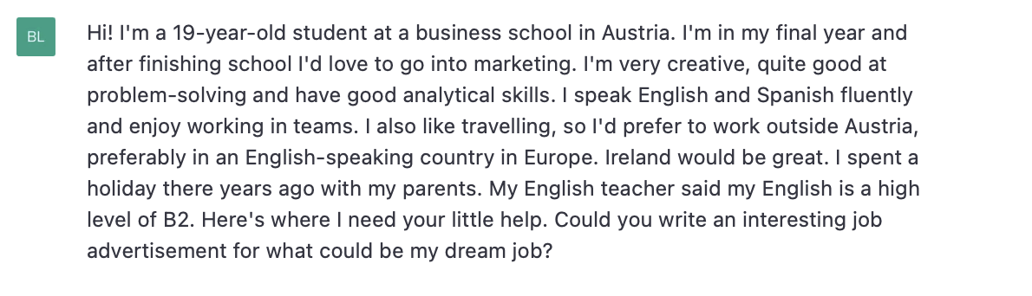

- Send off your request and wait for ChatGPT to generate your advert.
Here is ChatGPT’s response to the prompt above:
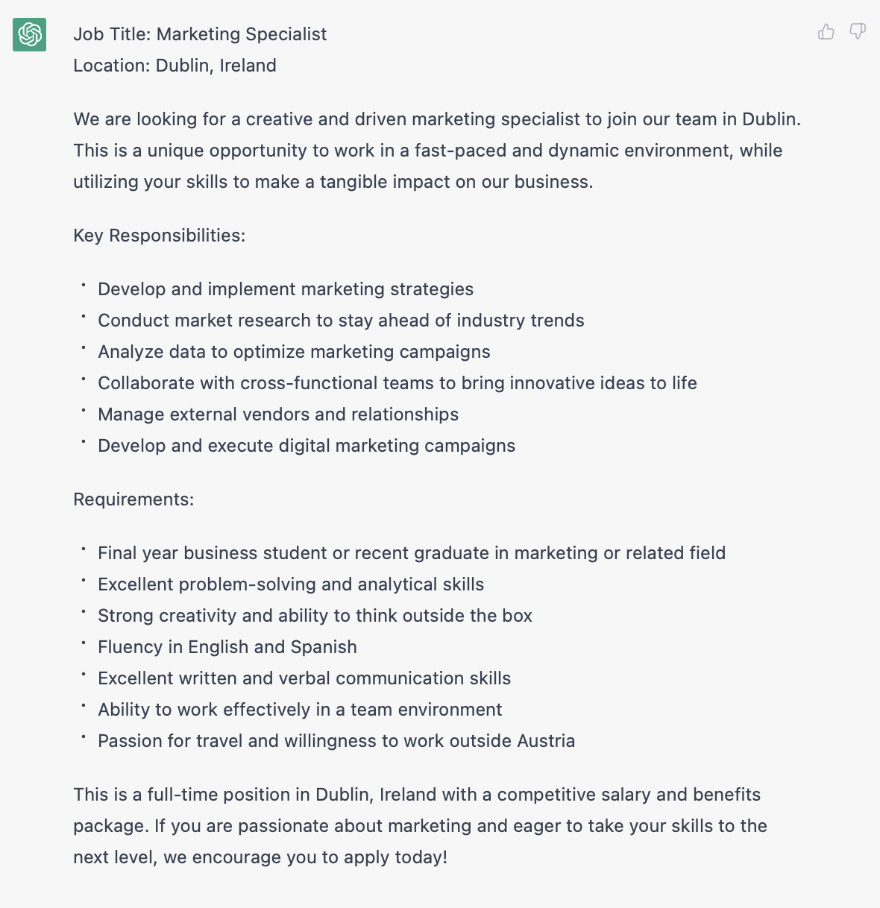

- If you think ChatGPT has created an advert for a job that meets your expectations, write another prompt. This time tell ChatGPT that you would like to prepare for a possible job interview and want ChatGPT to help you prepare for it by asking you questions that frequently come up in interviews for such a job. You may also add that you want ChatGPT to assess your interview and give you feedback at the end. It is important to inform ChatGPT that you want it to ask its questions one at a time and wait for your answer before it asks its next question.
It might be helpful if you re-read the job advert and prepare for interview before you send off your prompt and start the job interview.
Here is a sample prompt:

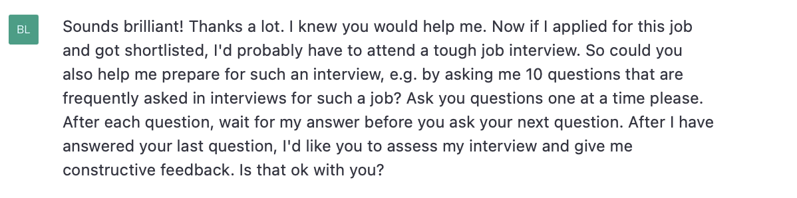
If you don’t think the job advertised is right for you, just ask ChatGPT to generate another one for you. It may help to refine your prompt.
- All the best for your job interview!

Here is an example:

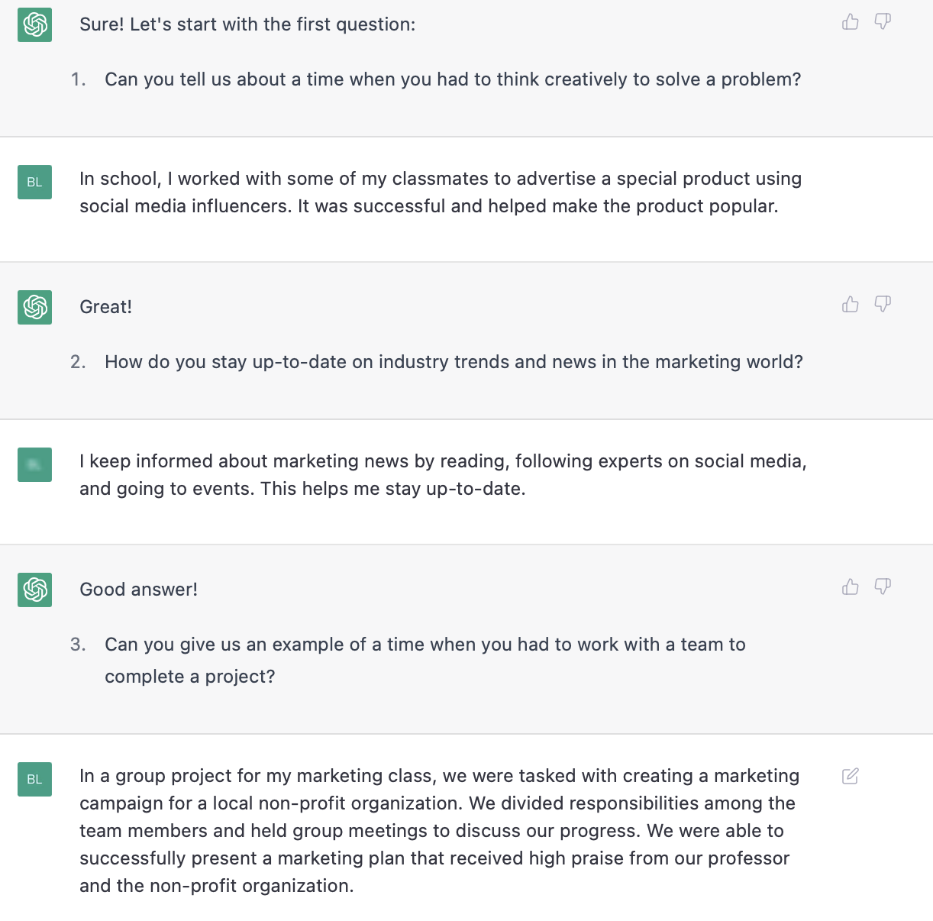

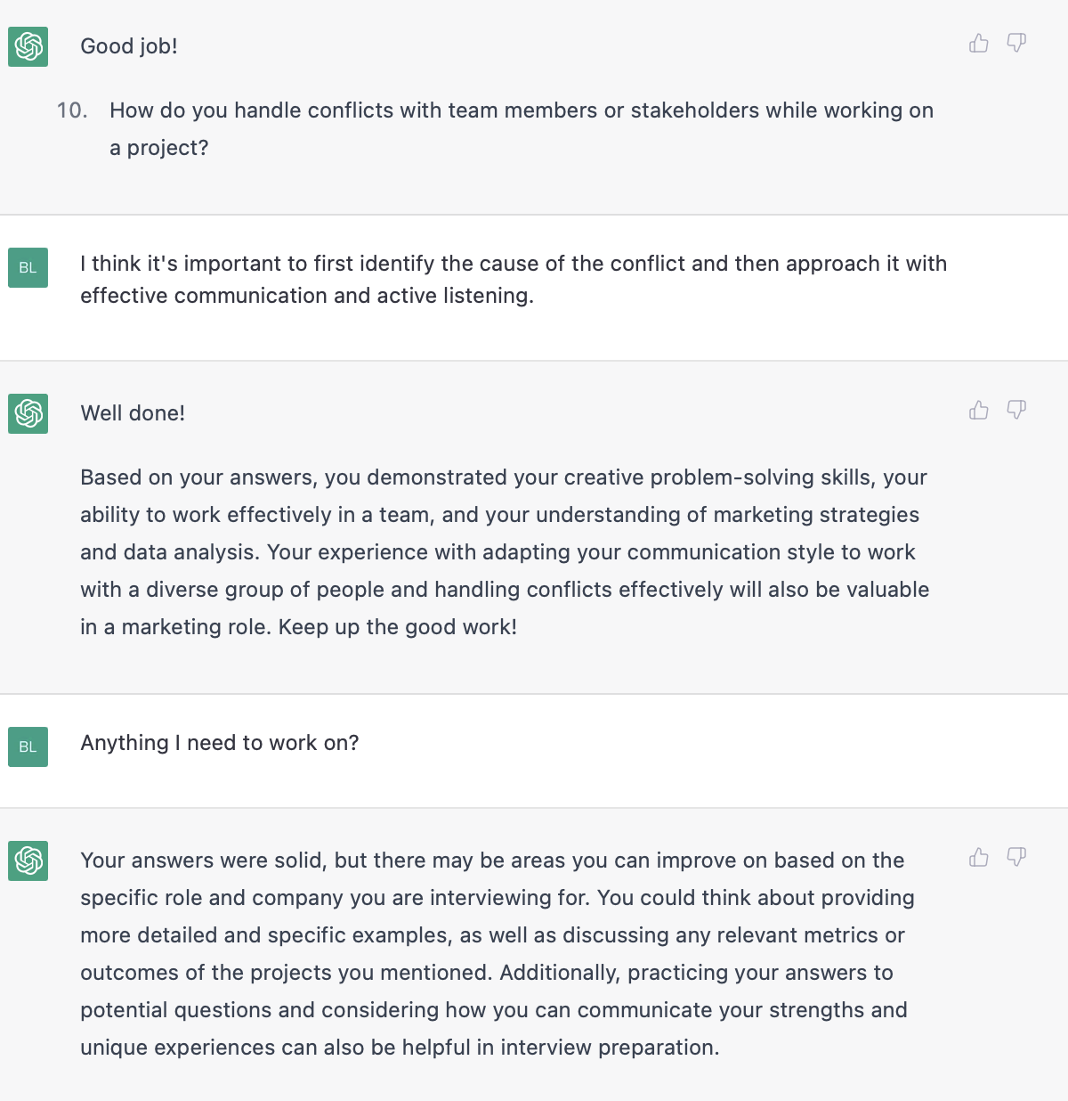

If ChatGPT’s assessment and feedback is difficult to understand, ask for a simplified version of its assessment and feedback.

