Subject: Geography
Topic: Marine Plastic Pollution
Farbcode:
Blau hinterlegt. = Bloom’sche Taxonomie angewandt.
Grün hinterlegt = Scaffolding angewandt

Activity types | - Brainstorming, taking notes  - Reading for gist, interpreting, discussing (=understanding, analyzing)  - Matching words and definitions  - Reading for gist, mind-mapping, writing a summary (=understanding)  - Watching a video, taking notes  - Designing a poster and an infographic (=creating)
Classroom format | Partner-work, Individual work, Whole-class lockstep, Whole-class frontal, Groupwork (Lockstep: https://scottthornbury.wordpress.com/2010/04/12/l-is-for-lockstep/)
Time needed | 2-3 lessons
Procedure | - Warm-Up  To activate the students’ schemata, the students reflect upon their own daily use of plastic products.  - Teaching Pre-Knowledge  Students read two short texts and interpret two infographics with a partner. Moreover, students learn more about marine plastic pollution and the garbage patches in our oceans. Finally, they discuss the effects of marine plastic pollution on humans and wildlife.  - Lexical pre-teaching to the factual text: Vocabulary matching  Students match words from the following factual text with their English definition.  - Reading the text  Students read the text “The world's plastic pollution crisis explained”.  - While reading exercise: Reading for gist  Students come up with a mind-map including the most important information of the text. They should be able to provide a written summary with the help of the mind-map.  - Follow-up activities  Students can choose from a variety of follow-up tasks
Resources needed | Handout, computer/mobile (video)
Content-related learning outcomes | - students get an overview/a basic knowledge about marine plastic pollution  - students reflect upon their own use of plastic and how to reduce plastic products in their daily lives  - students become aware of the fact that marine plastic harms humans and wildlife
Language-related learning outcomes | - students can read for general and detailed information  - students can summarize a text  - students can extract information from a text and create a mind map  - students can present the information contained in the factual text

① Warm-Up

- Think about a typical day in your life: Which role do plastics play in your life? Take notes and exchange your ideas with your partner.

___________________________________________________________
___________________________________________________________
___________________________________________________________
___________________________________________________________
___________________________________________________________
___________________________________________________________

- Take down 5 areas of life that heavily depend on the use of plastics:

      - ________________________________
      - ________________________________
      - ________________________________
      - ________________________________
      - ________________________________

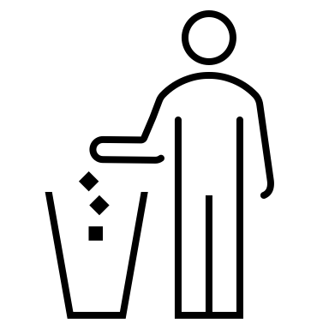
- What happens to (plastic) products when not needed anymore? Discuss with a partner and take notes!

___________________________________________________________
___________________________________________________________
___________________________________________________________

② Pre-Knowledge


Work with a partner. Read the following text and discuss the infographics. Take notes.
Can we clean up the mess?
Much of the planet is swimming in discarded plastic, which is harming animal and possibly human health. Can it be cleaned up?
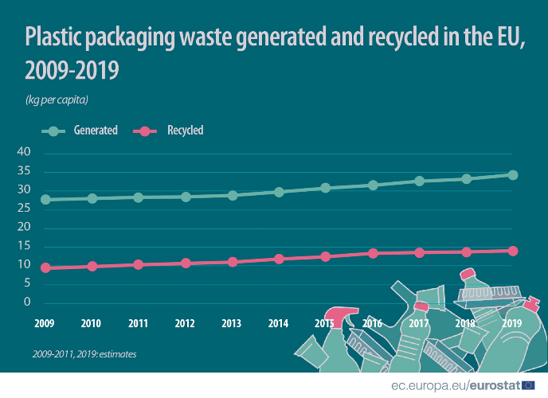
Plastic pollution has become one of the most pressing environmental issues, as rapidly increasing production of disposable plastic products overwhelms the world’s ability to deal with them. Plastic pollution is most visible in developing Asian and African nations, where garbage collection systems are often inefficient or non-existent. But the developed world, especially in countries with low recycling rates, also has trouble properly collecting discarded plastics. Plastic trash has become so ubiquitous it has prompted efforts to write a global treaty negotiated by the United Nations.
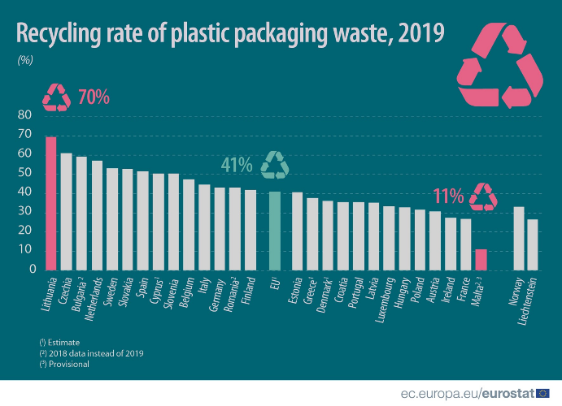

___________________________________________________________
___________________________________________________________
___________________________________________________________
___________________________________________________________
___________________________________________________________

Work with a new partner. Read the following text and have a look at the infographic. Then do the next task.
Marine plastic pollution
Most of the plastic trash in the oceans, Earth’s last sink, flows from land. Trash is also carried to sea by major rivers, which act as conveyor belts, picking up more and more trash as they move downstream. Once at sea, much of the plastic trash remains in coastal waters. But once caught up in ocean currents, it can be transported around the world.
On Henderson Island, an uninhabited atoll in the Pitcairn Group isolated halfway between Chile and New Zealand, scientists found plastic items from Russia, the United States, Europe, South America, Japan, and China. They were carried to the South Pacific by the South Pacific gyre, a circular ocean current.
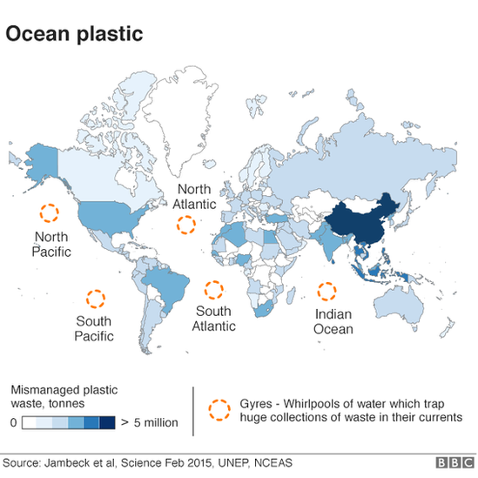
Garbage patches in the ocean
Discuss possible harm to humans and wildlife because of plastic trash in the oceans. Don’t forget to take short notes.
___________________________________________________________
___________________________________________________________
___________________________________________________________
___________________________________________________________
Picture taken from
https://www.bbc.com/news/science-environment-43490235
③ Lexical Pre-teaching: Matching exercise

- Match the words with their definitions. Afterwards, compare your results with a partner.

 | WORD |  | DEFINITION/SYNONYM
1 | to accelerate  ex.: The pace of change has begun to accelerate. |  | a substance that is added in small amounts to something, especially food, to improve it, give it colour, make it last longer, etc.
2 | incubator  ex.: Their baby was so small she spent three weeks in an incubator before going home. |  | a set of animals or plants in which the members have similar characteristics to each other and can breed with each other
3 | additives  ex.: The food is mainly vegan, with no additives or chemicals. |  | the act of becoming caught or twisted in something; the state of being caught or twisted in something
4 | to accumulate  ex.: I seem to have accumulated a lot of books. |  | to consider sth.
5 | species  ex.: Over a hundred species of insect are found in this area. |  | the state in which somebody suffers or dies because they have no food
6 | endangered  ex.: Mountain gorillas are an endangered species. |  | to increase speed
7 | entanglement  ex.: Many dolphins die each year from entanglement in fishing nets. |  | to find and bring back something
8 | starvation  ex.: The animals had died of starvation. |  | in danger of being harmed or lost
9 | to retrieve  ex.: They've managed to retrieve most of the data. |  | to gradually get more and more of something over a period of time
10 | to take sth. into account  ex.: I think you have to take into account that he's a good deal younger than the rest of us. |  | a piece of equipment in a hospital that new babies are placed in when they are weak or born too early, to help them survive
Definitions and sample sentences taken from
https://dictionary.cambridge.org/
https://www.oxfordlearnersdictionaries.com/
④ Factual Text
Read the following text and do the next task. The words in green have been explained in the task before.

The world's plastic pollution crisis explained
Plastics made from fossil fuels are just over a century old. Production and development of thousands of new plastic products accelerated after World War II, so transforming the modern age that life without plastics would be unrecognizable today. Plastics revolutionized medicine with life-saving devices, made space travel possible, lightened cars and jets—saving fuel and pollution—and saved lives with helmets, incubators, and equipment for clean drinking water.
The conveniences plastics offer, however, led to a throw-away culture that reveals the material’s dark side: today, single-use plastics account for 40 percent of the plastic produced every year. Many of these products, such as plastic bags and food wrappers, have a lifespan of mere minutes to hours, yet they may persist in the environment for hundreds of years.

Some key facts:
- Half of all plastics ever manufactured have been made in the last 15 years.
- Production increased exponentially, from 2.3 million tons in 1950 to 448 million tons by 2015. Production is expected to double by 2050.
- Every year, about 8 million tons of plastic waste escapes into the oceans from coastal nations. That’s the equivalent of setting five garbage bags full of trash on every foot of coastline around the world.
- Plastics often contain additives making them stronger, more flexible, and durable. But many of these additives can extend the life of products if they become litter, with some estimates ranging to at least 400 years to break down.
An enormous amount of plastic trash can already be found in the ocean, and it is said that plastic trash flowing into the seas will nearly triple to 29 million metric tons by 2040 without drastic actions. No one knows for certain how much plastic, which is virtually indestructible, has accumulated in the seas. The best guess, made in 2015, was about 150 million metric tons. Assuming things remain the same, it is estimated that accumulation will become 600 million metric tons by 2040.

Microplastics
Once at sea, sunlight, wind, and wave action break down plastic waste into small particles, often less than one-fifth of an inch across. These so-called microplastics are spread throughout the water column and have been found in every corner of the globe, from Mount Everest, the highest peak, to the Mariana Trench, the deepest trough.
Microplastics are breaking down further into smaller and smaller pieces. Plastic microfibers, meanwhile, have been found in municipal drinking water systems and drifting through the air. Hence, microplastic gradually enters the human’s food chain (= biomagnification).
Harm to wildlife
Millions of animals are killed by plastics every year, from birds to fish to other marine organisms. Nearly 700 species, including endangered ones, are known to have been affected by plastics. Nearly every species of seabird eats plastics.
Most of the deaths to animals are caused by entanglement or starvation. Seals, whales, turtles, and other animals are strangled by abandoned fishing gear or discarded six-pack rings. Microplastics have been found in more than 100 aquatic species, including fish, shrimp, and mussels destined for our dinner plates. In many cases, these tiny bits pass through the digestive system and are expelled without consequence. But plastics have also been found to have blocked digestive tracts or pierced organs, causing death. Stomachs so packed with plastics reduce the urge to eat, causing starvation.
Plastics have been consumed by land-based animals, including elephants, hyenas, zebras, tigers, camels, cattle, and other large mammals, in some cases causing death.
Stemming the plastic tide
Once in the ocean, it is difficult—if not impossible—to retrieve plastic waste. But once plastics break down into microplastics and drift throughout the water column in the open ocean, they are virtually impossible to recover.
The solution is to prevent plastic waste from entering rivers and seas in the first place, many scientists and conservationists—including the National Geographic Society—say. This could be accomplished with improved waste management systems and recycling, better product design that takes into account the short life of disposable packaging, and reduction in manufacturing of unnecessary single-use plastics.
Text taken and adapted from
https://www.nationalgeographic.com/environment/article/plastic-pollution
https://www.nationalgeographic.com/science/article/plastic-trash-in-seas-will-nearly-triple-by-2040-if-nothing-done
⑤ Mind Map about Factual Text

- Complete the mind-map with the most important facts from the text you have just read.

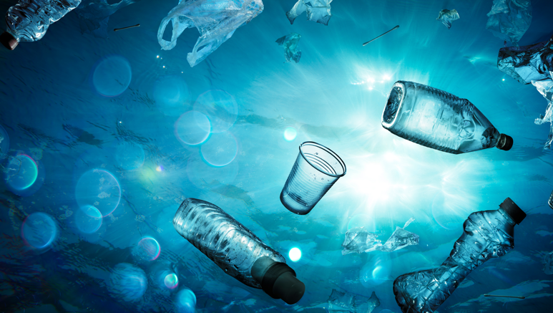


- Use your mind map to write a short summary (5-7 sentences) of the factual text (Task 4).
___________________________________________________________
___________________________________________________________
___________________________________________________________
___________________________________________________________
___________________________________________________________
___________________________________________________________
___________________________________________________________
Picture taken from Adobe Stock.
⑥Follow-up Activities

- Graphically represent biomagnification (as mentioned in the factual text).



- Watch the following video and take notes on how to reduce plastic waste in our daily lives. Also, add your own ideas and suggestions.


- Group work:
  - Design a poster to draw attention to marine plastic pollution.
  - Include information about the Great Pacific Garbage Patch.

⑦ Key to Exercises
Lexical Pre-teaching: Matching exercise
- Match the words with their definition.
 | WORD |  | DEFINITION/SYNONYM
1 | to accelerate  ex.: The pace of change has begun to accelerate. | 3 | a substance that is added in small amounts to something, especially food, in order to improve it, give it colour, make it last longer, etc.
2 | incubator  ex.: Their baby was so small she spent three weeks in an incubator before going home. | 5 | a set of animals or plants in which the members have similar characteristics to each other and can breed with each other
3 | additives  ex.: The food is mainly vegan, with no additives or chemicals. | 7 | the act of becoming caught or twisted in something; the state of being caught or twisted in something
4 | to accumulate  ex.: I seem to have accumulated a lot of books. | 10 | to consider sth.
5 | species  ex.: Over a hundred species of insect are found in this area. | 8 | the state in which somebody suffers or dies because they have no food
6 | endangered  ex.: Mountain gorillas are an endangered species. | 1 | to increase speed
7 | entanglement  ex.: Many dolphins die each year from entanglement in fishing nets. | 9 | to find and bring back something
8 | starvation  ex.: The animals had died of starvation. | 6 | in danger of being harmed or lost
9 | to retrieve  ex.: They've managed to retrieve most of the data. | 4 | to gradually get more and more of something over a period of time
10 | to take sth. into account  ex.: I think you have to take into account that he's a good deal younger than the rest of us. | 2 | a piece of equipment in a hospital that new babies are placed in when they are weak or born too early, in order to help them survive

