Competences | Processing text in speech, Processing text in writing, Spoken Production, Spoken Interaction, Collaborating in a group
Level | FR: B1, E: B2
Topic | Stress
Methods | Individual work, group work
Time | 4 lessons of 50 min.  The follow-up bilingual speaking task is done at home and recorded.
Language requirements | Students have a good range of vocabulary and structures related to the topics work and school.  They can give advice in both languages.
Material | At least 1 laptop or computer in the classroom for viewing the video and the padlet;  students can also use their smartphone or their own tablet.
Sources | Tasks: own idea  Placemat Method: https://heterogenitaet.bildung-rp.de/fileadmin/user_upload/lernen-in-vielfalt.bildung-rp.de/03_Materialien/3_2_Aktivierung/3_2_5_Placemat/Placemat_Download.pdf  Model Placemat: https://lehrerfortbildung-bw.de/u_gewi/ethik/gym/bp2004/fb2/2_analyse/w4_ohne_texte/5_place/  Texts in English adapted from https://www.nibusinessinfo.co.uk/content/common-causes-stress-work  Infographic: http://www.best-infographics.com/deal-stress-workplace-infographic/  Text in French adapted from https://mesdefisjenparle.com/webzine/sept-moyens-de-gerer-le-stress-comme-etudiant  Picture: www.pixabay.com
Further details | Lesson 1: Worksheet 1 English  Lesson 2: Worksheet 1 French  Lessons 3 and 4: Worksheet 2 English + French  There should be one placemat for each group of three or four students, so if there are 16 students in a group, there will be two placemats 1 and two placemats 2, for example. The placemats need to be prepared in advance.
TechTools | Padlet, Canva  If you would like to use the suggested padlet (https://frama.link/PadletRaisonsStress), follow these steps:  - Click on the link to open the padlet and sign up.  - As soon as you have your own account, copy the padlet by clicking on “REMAKE“.  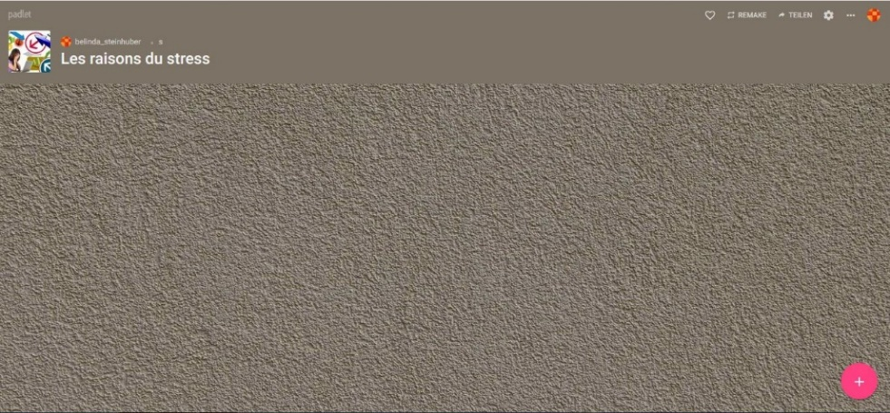

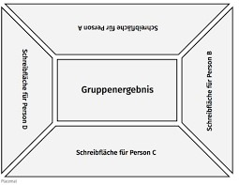
Form groups of three or four.
Find a table with either placemat 1 or placemat 2 on it.
Sit around the table in such a way that each team member faces a free field.
Stay with your group throughout the whole activity.

Placemat 1
Group result

Expected Outcome
Placemat 1: Reasons for stress at the workplace
Placemat 2: Effects of stress at the workplace
Task 1
Think about reasons for / effects of stress and write them into your free field of the placemat.
Task 2
Placemat 1:
Watch one of the two videos (or both):
https://www.youtube.com/watch?v=cs6vNXcMuxs
https://www.youtube.com/watch?v=6OzKD1YWHRI (first 2 minutes only)
or read the text “How to deal with stress - Common causes of stress at work”
Placemat 2:
Read the text “How to deal with stress - Identify signs of stress in employees” and study the infographic.

- Add further ideas to your field.
Task 3
If you have just worked on placemat 1, go to a placemat 2.
If you have just worked on placemat 2, go to a placemat 1.
Add your ideas to one of the fields or just study your colleagues’ ideas.
Task 4
Return to your original placemat.
- Discuss the different ideas you find on your placemat and agree on the ten most important reasons/effects.
- Write them into the field in the middle.

How to deal with stress

Common causes of stress at work
It's important to recognise the common causes of stress at work so that you can take steps to reduce stress levels where possible. Workplace stress can be caused by a number of factors – from heavy workloads and over-promotion to bullying and blame culture.
Some common causes of stress in the workplace include:
- Excessively high workloads, with unrealistic deadlines making people feel rushed, under pressure and overwhelmed.
- Insufficient workloads, making people feel that their skills are being underused.
- A lack of control over work activities.
- A lack of interpersonal support or poor working relationships leading to a sense of isolation.
- People being asked to do a job for which they have insufficient experience or training.
- Difficulty settling into a new promotion, both in terms of meeting the new role's requirements and adapting to possible changes in relationships with colleagues.
- Concerns about job security, lack of career opportunities, or level of pay.
- Bullying or harassment.
- A blame culture within your business where people are afraid to get things wrong or to admit to making mistakes.
- Weak or ineffective management which leaves employees feeling they don't have a sense of direction. Or over-management, which can leave employees feeling undervalued and affect their self-esteem.
- Multiple reporting lines for employees, with each manager asking for their work to be prioritised.
- Failure to keep employees informed about significant changes to the business, causing them uncertainty about their future.
- A poor physical working environment, e.g. excessive heat, cold or noise, inadequate lighting, uncomfortable seating, malfunctioning equipment, etc.

https://www.nibusinessinfo.co.uk/content/common-causes-stress-work [last accessed 30th May 2019]

How to deal with stress

Identify signs of stress in employees
Individuals suffering from stress often display a range of signs that may be noticed by colleagues and other managers.
These signs include:
- tiredness and irritability
- reduced quality of work
- indecisiveness and poor judgement
- loss of sense of humour
- physical illness such as headaches, nausea, aches and pains
- seeming jumpy or ill-at-ease, or admitting to sleeping badly
- increased sick leave
- poor timekeeping
- changes in working day patterns - perhaps by staying late or taking work home

Signs of stress in groups
You should also look for signs of more widespread problems among groups of employees, for example:
- arguments and disputes between staff
- general absenteeism
- an increase in grievances and complaints
- greater staff turnover
You also need to watch out for signs that your own stress levels are rising.

https://www.nibusinessinfo.co.uk/content/common-causes-stress-work [last accessed 30th May 2019]

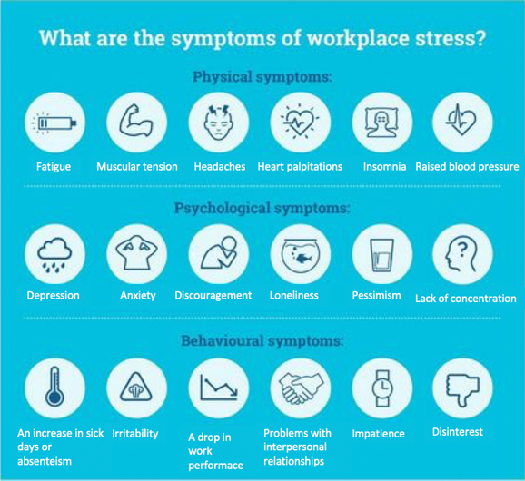

http://www.best-infographics.com/deal-stress-workplace-infographic/

Tâche 1
Travaillez en groupes de 3 ou 4 personnes.
Réfléchissez aux raisons du stress à l’école et notez-les sur une feuille.

Tâche 2
- Mettez-vous avec un autre groupe et échangez vos idées.
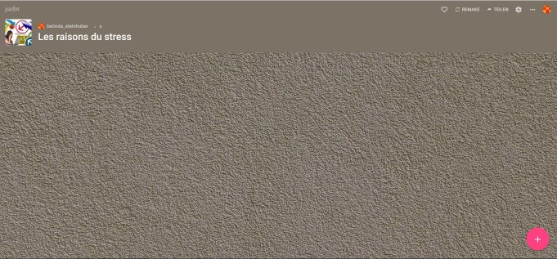
- Ouvrez le Padlet et mettez un post avec toutes les raisons que vous avez trouvées.
- Lisez les posts des autres groupes.

Tâche 3
Travaillez à deux. Lisez le texte « Sept moyens de gérer le stress comme étudiant ».
- Dans le texte, cherchez les équivalents en français de ces expressions en anglais :

Anglais | Français
- a trick  - an obstacle  - a goal  - activities which prevent you from reaching your goals  - to accomplish sth.  - to take healthy breaks  - to breathe  - to make good use of oxygen and food  - a sign, a hint  - to deceive | __________________________________________  __________________________________________  __________________________________________  __________________________________________  __________________________________________  __________________________________________  __________________________________________  __________________________________________  __________________________________________  __________________________________________  __________________________________________

- Résumez l’essentiel de chaque conseil avec vos propres mots (en français et en anglais).
- Notez vos résumés sur une feuille.

Tâche 4
Mettez-vous avec deux autres paires.
Comparez vos résumés et discutez sur d’éventuelles différences (en français).


Sept moyens de gérer le stress comme étudiant

Être étudiant est une expérience exaltante et laborieuse, mais également souvent très stressante. Voici quelques astuces pour bien gérer ce stress et profiter au maximum de la vie !

1. Décider de changer
Ce n’est que lorsque nous nous prenons en main et décidons de changer notre vie pour de vrai que nous devenons capables de gérer le stress.
2. Veiller sur ce qui nous entoure
La vie est semblable à une tasse de thé. Nous pouvons y ajouter tellement de choses ! Si vous remplissez votre tasse avec des activités qui font obstacle à vos buts, vous n’aurez pas assez de temps pour accomplir ces buts. Les mauvais choix augmentent le stress alors que les bonnes décisions produisent la joie et la satisfaction.
3. Se remettre des déceptions
Félicitez-vous pour le bien que vous accomplissez et consolez-vous lorsque les choses ne se passent pas comme voulu en reconnaissant qu'il est impossible de tout contrôler dans la vie.
4. Prendre des pauses-santé
Lorsque vous vous détendez en faisant des activités qui vous portent de la joie, vous renouvelez votre esprit. Chaque jour, prenez des pauses-santé.
Méditer, écouter de la musique douce, passer du temps avec des amis et les personnes que vous aimez, respirer consciemment… voilà des moyens efficaces de se détendre. Si votre esprit est rempli de pensées stressantes, vous n’êtes pas vraiment détendu ! Chaque jour, mettez un point d’honneur à être calme.
La santé et la vitalité dépendent de la capacité de votre corps à utiliser efficacement l’oxygène et les aliments. L’exercice physique vous tient en forme et permet également la production d’endorphines réputées bénéfiques pour l’humeur, ce qui fait de l’activité physique une arme efficace contre le stress. Bougez chaque jour !
5. Bien se nourrir
Écoutez votre corps. Il vous donne des indices sur ses besoins et ses problèmes. Une alimentation déséquilibrée est cause de stress dans le corps. Il n’est pas difficile d’avoir la bonne information et de faire de bons choix. Mangez de la nourriture saine ! Votre corps vous en remerciera !
6. Dormir suffisamment
La plupart des gens ont besoin d’au moins sept heures de sommeil par nuit. Il est plus facile de respecter ce besoin si l'on se couche et se lève à des heures fixes. Saviez-vous que si vous ne dormez pas assez, vous pouvez perdre jusqu’à 50 % de vos forces le jour suivant (votre capacité à réfléchir, à répondre et à juger) ? Couchez-vous tôt ! Ne prenez pas pour excuse le travail que vous voulez finir à temps. Organisez votre agenda de sorte à accomplir vos travaux sans couper dans vos heures de sommeil.
7. Chercher à s’épanouir
Découvrez ce qui vous enthousiasme et ce qui vous démoralise. Prendre conscience de ces choses vous aidera à prendre de bonnes décisions. Suivez également votre intuition. Votre bon sens ne vous décevra jamais. Éveillez-vous et soyez attentif. Vous apprenez pas mal de choses de cette manière !
La vie est très courte. Chaque instant est précieux : profitez-en à fond. Si vous le faites, vous aurez moins de stress, moins de problèmes physiques, et vous serez plus productifs. En toute circonstance, regardez le côté agréable, plaisant, bon, ou joyeux de la situation, même lorsque la vie paraît injuste.
https://mesdefisjenparle.com/webzine/sept-moyens-de-gerer-le-stress-comme-etudiant (abridged)

F
F

E
Form groups of three or four.
Find a table with either placemat 1 or placemat 2 on it.
Sit around the table in such a way that each team member faces a free field for English or for French.
Group result

E

Expected Outcome
Placemat 1: 10 tips to reduce stress at the workplace
Placemat 2: 10 tips to reduce stress at school
Task 1
Work out some tips and write them into your field.
Task 2
Move to the next field (different language) or turn the placemat.
Add your own ideas to the field or just study the ideas of the other team members.
Task 3
Discuss the ideas on the placemat in your team (using both languages). Decide on the 10 best tips.
Task 4
Present your 10 final tips to the other groups – 5 tips in English, 5 tips in French.
If you like, you can create a poster as support.
You may use a sheet of flipchart paper or use www.canva.com to create your poster.

Follow-up 1 – Planning a workshop (language: French)
Projeter une journée d’ateliers
Travaillez en groupes de 4 ou 5 personnes.
Vous devez organiser une journée d’ateliers sur le thème du stress pour l’entreprise où vous travaillez.
- Discutez le contenu des différents ateliers.
- Décidez comment la journée sera organisée.
- Etablissez un programme pour la journée.

Follow-up 2 – Speaking task (French and English)

Situation

You work for the Human Resources Department of an international company. Your head of department has noticed that an increasing number of members of staff are showing symptoms of stress. The management has decided to react and has asked you to organize a workshop day on the topic of stress. At the start, you give a short introductory talk for the participants.
As the main languages used in the company are English and French, your talk needs to be bilingual.
- Give reasons why the company has decided to offer this workshop day (stress symptoms, consequences for the company etc.).
- Inform about the programme of the workshop day.
- Present further measures the company is going to take in order to increase the well-being and the performance of the staff.

- Present your ideas.
- Make sure to show your competence in both languages.
- You are not expected to deal with all parts of the task equally in both languages. You do not have to cover all bullet points at the same length in both languages, and you do not always have to give the same information in both languages. Do the task in both languages making use of the linguistic range you possess, which means that you do not have to be able to express the same things in French (level B1) as in English (level B2).
- Decide when it is necessary to switch between the languages in order to satisfy all members of your audience.
- Your talk should last about 5 minutes.

Record your talk on your mobile and send it to your teacher.

After this unit I can … | ☺ | 😐 | ☹
… discuss in English and in French how to cope with stress at work and at school.
... give advice in both languages how to cope with stress.
... understand an English text on stress at the workplace.
… understand a French text on how to deal with stress as a student.
… summarise the important points made in longer texts and use the information to complete a task.
… summarise information from several sources and use it to complete a task.

